Ideation Phase
Brainstorm & Idea Prioritization Template

Date | 29.09.2026
Team ID | 6AP3D7136F290BE8A6B32917
Project Name | AI FAQ ASSISTANT API
Maximum Marks | 4 Marks

Brainstorm & Idea Prioritization Template
Brainstorming provides a free and open environment that encourages everyone within a team to participate in the creative thinking process that leads to problem solving. Prioritizing volume over value, out-of-the-box ideas are welcome and built upon, and all participants are encouraged to collaborate, helping each other develop a rich amount of creative solutions.
Use this template in your own brainstorming sessions so your team can unleash their imagination and start shaping concepts even if you're not sitting in the same room.
Reference: https://www.mural.co/templates/brainstorm-and-idea-prioritization

Step-1: Team Gathering, Collaboration and Select the Problem Statement
The team members discussed the common problems faced in managing Frequently Asked Questions. The discussion focused on the difficulties in manually creating and maintaining FAQ content, searching for required information, and providing quick answers to user questions.
The team identified the following major problems:
- Difficulty in creating and maintaining FAQ information manually.
- Difficulty in finding the required FAQ when the number of records increases.
- Time required to prepare new question-and-answer content.
- Lack of intelligent answers for questions that are not available in the FAQ database.
- Need for secure authentication to protect private FAQ operations.
- Need for proper database validation and error handling.
After discussion and collaboration, the team selected the following problem statement:
Problem Statement:
Develop a secure and intelligent RESTful API that manages FAQ information, provides keyword-based FAQ search, and generates AI-powered answers and FAQ content using Google Gemini AI.
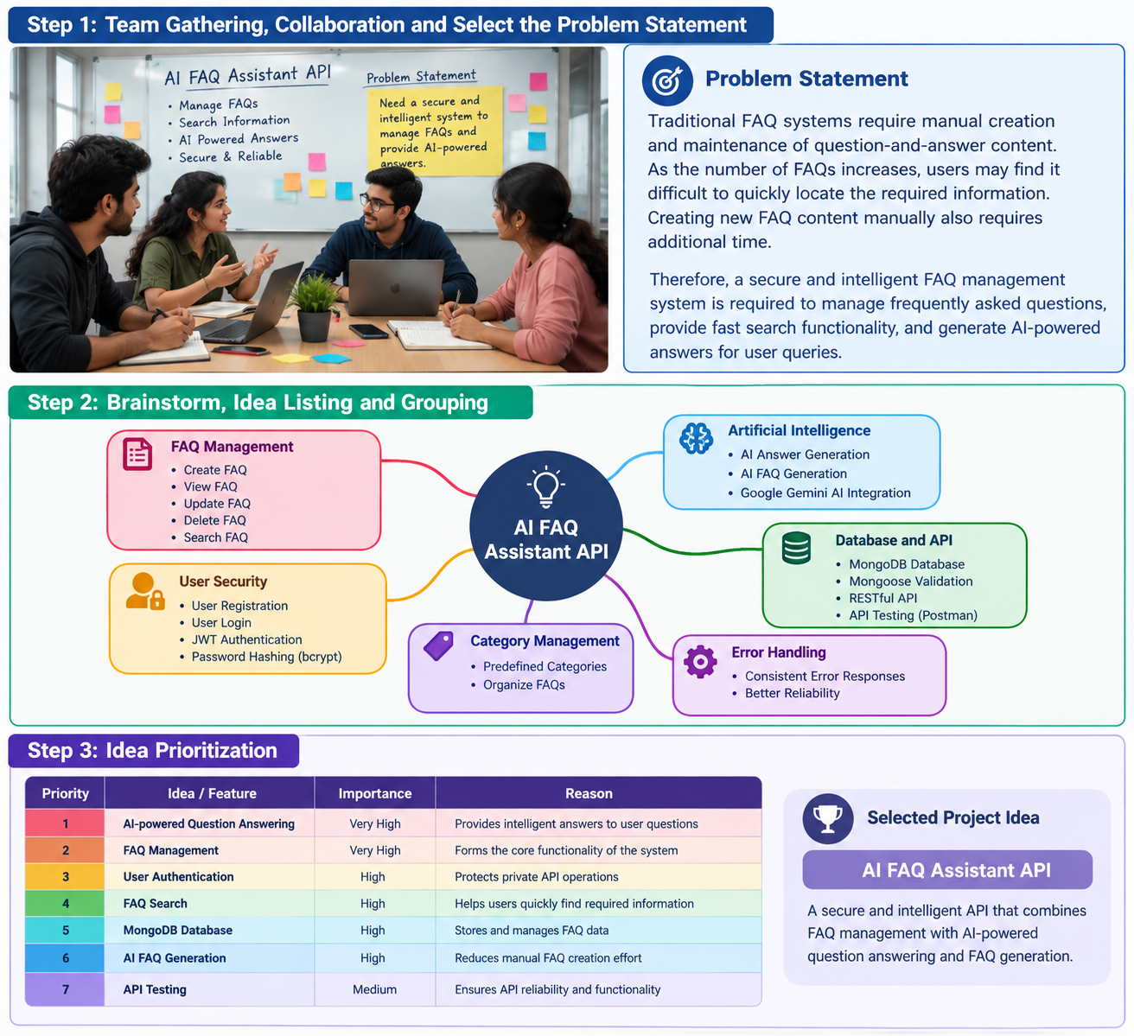
Team Gathering, Collaboration and Problem Statement Selection

Step-2: Brainstorm, Idea Listing and Grouping
The team members brainstormed different ideas for solving the identified problem. The ideas were discussed and grouped according to the major requirements of the proposed AI FAQ Assistant API.

FAQ Management
- Create FAQ
- View FAQ
- Update FAQ
- Delete FAQ
- Search FAQ

User Security
- User Registration
- User Login
- JWT Authentication
- Password Hashing using bcrypt

Artificial Intelligence
- AI Answer Generation
- AI FAQ Generation
- Google Gemini AI Integration

Database and API
- MongoDB Database
- Mongoose Validation
- RESTful API
- API Testing using Postman

System Reliability
- Centralized Error Handling
- Request Validation
- Secure API Access
- Consistent JSON Responses
The above ideas were grouped according to their functionality and importance to form the basic requirements of the project.

Brainstorming, Idea Listing and Grouping

Step-3: Idea Prioritization
After brainstorming and grouping the ideas, the team prioritized the proposed features based on their importance, usefulness, security, feasibility, and contribution to the
project.Based on the prioritization, the team selected AI FAQ Assistant API as the final project idea.
The selected project combines FAQ management, secure user authentication, keyword-based search, MongoDB database management, and Google Gemini AI services into a single RESTful backend system.

Idea Prioritization

Priority | Idea / Feature | Importance | Reason
1 | AI-powered Question Answering | Very High | Provides intelligent answers to user questions
2 | FAQ Management | Very High | Forms the core functionality of the system
3 | User Authentication and Security | High | Protects private API operations
4 | FAQ Search | High | Helps users quickly find required information
5 | AI FAQ Generation | High | Reduces manual FAQ creation effort
6 | MongoDB Database Management | High | Stores and manages user and FAQ information
7 | API Testing | Medium | Verifies API functionality and reliability
8 | Centralized Error Handling | Medium | Provides consistent and reliable error responses

